Lifetime Tester
Report Analysis User Manual
Document ID: 23-10-051-VTF-CBAIC-UM
Rev.: 1.0
Captronics Systems Pvt Ltd
 | Name | Signature | Date
Prepared By | Ananth A
Reviewed By | Prabhakaran T J
Approval By | Midhunseelan O S

Customer
 | Name | Signature | Date
Reviewed By | Abhay Kumar |  | 01 April 2025
Approved By

Document ID | 23-10-051-VTF-CBAIC-UM
Document Name: | Report Analysis User Manual
Document No.: | R/PP-03/25
Project/Product Name: | Lifetime Tester
Project/Product Code: | 23-10-051-VTF-CBAIC
Revision Status: | 1.0

Change Summary

Release No. | Date | Changed By | Change Description
Version 1.0 | 04-01-2025 | Ananth A | Initial Version

Table of Contents
Change Summary 2
Table of Contents 3
List of Figures 5
1 Introduction 6
2 Scope 6
3 Tools Overview 6
4 Software Details 7
4.1 How to Launch LTT Application 7
4.2 User Interface Flow 7
4.3 Main Screen 8
5 Test Log Import and Export Details 9
5.1 Test Log Import/ Export Screen Detail 9
5.2 Procedure to Import the Test Log 10
5.2.1 Browse Test Log file 11
5.2.2 Start Importing 12
5.2.3 Import in Progress 13
5.2.4 Import Successful 14
5.2.5 Import Status Update 15
5.3 Procedure to Export theTest Log 16
5.3.1 Browse for Folder Selection 17
5.3.2 Export Test log and Status 18
5.3.3 Export Successfully Completed Message 19
6 Test Log Selection 20
Select 'Test Log' as the option, because only then will the 'Other Data Analysis' button be enabled. This allows you to view and simulate post-analysis, enabling access to the data view. Error! Bookmark not defined.
6.1 Selected the Test Log Name 20
7 Test Information 21
7.1 Test Info View: 21
8 Errors Log 22
8.1 Analyzing Error Log 22
8.2 Test Socket wise Errors 23
8.2 Signal Selected and View Data 24
8.3 Procedure for Error Log – Selected the Test Mode Filter based Data View. Error! Bookmark not defined.
8.4 Selected the Cycle Number based Filter 25
8.5 View the FE and FF Frames for any Error 26
9 FE and FF frames 27
9.1 FE and FF Frame Data Window 27
9.2 Apply the Data Filter 28
9.3 Apply the Time Based Filter 29
9.4 View Selected the Frame 30
9.5 FE and FF Frame- Mode Filter 31
9.6 Export the Selected Data 32
10 Plot Signals 33
10.1 Procedure for Plot Signals: 33
10.2 Procedure for Validation of the Signals: 34
11 Export Data 35
11.1 Export the Data WIndow 35
11.2 Select the Table 36
11.3 Export the Data 37

List of Figures
Figure 1: Lifetime Tester Data Analyser Splash Screen 7
Figure 2: User Interface Flow 7
Figure 3: Main Screen 8
Figure 4: Import and Export Screen 9
Figure 5: Import Database File 10
Figure 6: Import Data Selection 11
Figure 7: Import Data File Displayed. 12
Figure 8: Import Data Inprograss 13
Figure 9: Import File Successful 14
Figure 10: Import Status Show for successfully Completed 15
Figure 11: Export the Database File 16
Figure 12: Export Database File Folder Selection 17
Figure 13: Export of the Selected Database File Displayed. 18
Figure 14: Export the Database file Successfully Completed. 19
Figure 15: Test Log Selected 21
Figure 16: Test Information View 21
Figure 17: Procedure for Error Log 22
Figure 18: Error Log – Test Socket and Signal Listed 23
Figure 19: Error Log Selected Signal and View Data 24
Figure 20: Error Log Selected Mode and Data View Error! Bookmark not defined.
Figure 21: Error Log – Selected Cycle and Data View 25
Figure 22: Error Log – Display FE and FF frames 26
Figure 23: FE and FF Frames 27
Figure 24: FE and FF Frames All Data Filter 28
Figure 25: FE and FF Frame Date and Time Filter 29
Figure 26: FE and FF Frame Selection Filter 30
Figure 27: FE and FF Frame and Test mode Filters 31
Figure 28: FE and FF Frame Export Data 32
Figure 29: Procedure for Plot Signals 33
Figure 30: Plot Signals - Validation 34
Figure 31: Procedure the Export Data 35
Figure 32: Export Data – Selected Table and Show Data. 36
Figure 33: Export Data as File Format 37

Introduction

The purpose of this document is to outline the user instructions for the Test Result Log, referred to as the “Report Analysis Tool for Lifetime Tester,” which is developed for analysis, verification, and validation purposes.

The core of the system is built on LabVIEW and SQL-based data acquisition within the Console Module. The console panel includes features such as Test Log Import and Export, Test Information, Error Log, FE FF Frame, Signal Plotting, and Export. It also supports report analysis, validation, and verification of the test systems.

Scope

The scope of this document is limited to describing the tool functionality of the Product Lifetime Tester Data analysis tool.
The system is designed to offer the following features to the user.
- Executing the developed LabVIEW Environment
- Generating reports for storage and management of SQL data.

Tools Overview

The report analysis tool is designed to review test logs recorded during the design or process validation (DV/PV) of a product in a lifetime tester (LTT). This tool provides an overview of the test, including test information, errors logged during the test, and graphical data visualizations. Additionally, it allows users to export data in Excel or CSV formats.

Software Details

How to Launch LTT Application
- Run the Data Analysis.exe application as an administrator; it's located as a shortcut on the PC desktop. Splash screen figure 1 appears in the desktop for few seconds.
- Application Locate in the "C:\Program Files\NI LTT\Data Analyzer Exe\Data Analysis.exe"
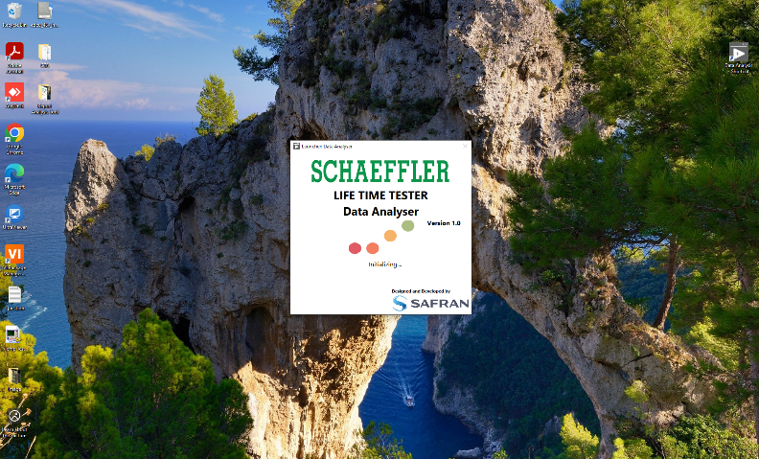
Figure 1: Lifetime Tester Data Analyser Splash Screen

User Interface Flow
The main screen of the Lifetime Tester provides the Report Analysis tool, allowing the user to access various software features of the system, such as data export and import, test information, error log, FE FF frame, signal plotting, and export. The software user interface flow is depicted in the schematic.
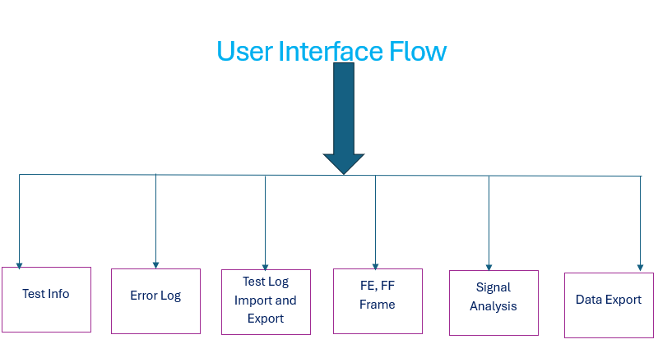
Figure 2: User Interface Flow

Main Screen
The main screen of the Report Analysis tool has the following buttons, as shown below. Only the Application Close, Test Log Import and Export button options are enabled.
- Select the Test Log button, if data is available, the options will be listed, referring to Section 6.
- If the Test Log button does not list any data, refer to Section 5.
- Option to select the Product Filter for Test Log.
- Option to select the Test Phase Filter for Test Log.
- Option to select the Test Name Filter for Test Log.
- Option to Refresh the Database Name List.
- Option to Delete the Listed Database Name.
- Option to select Frame Type (FE Frame and FF Frame) Filter.
- Option to select the Test Socket Filter.
- Option to select the Test Mode Filter.
- Option to set the Test Start and Stop Cycles Filter.
- Option to Reset the Values for Test Sockets, Test Mode, Start Cycle, and Stop Cycles.
- Select the display mode for the Report View screen from the following options: Test Info, Error Log, FE FF Frame, Signal Analysis, Data Export, and Test Log Import/Export.
6
7
4
5
1&22
3

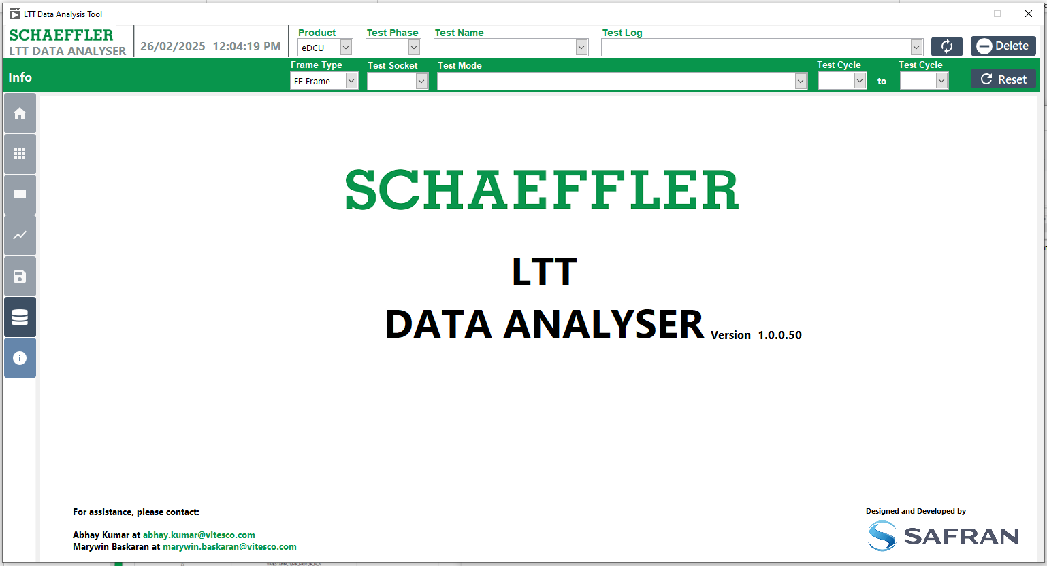
13
8
9
10
11
12
Figure 3: Main Screen

Test Log Import and Export Details

The Test Log Import and Export feature allows users to import and export SQL dump files for analysis purposes.
Typically, the Export Test Log is performed in the LTT System to export data, while the Import Feature is used in any system where the test log needs to be reviewed.
Test Log Import/ Export Screen Detail

- Click on icon to open the Test Log Import/Export screen.
- To import the database, click the "Import" tab button.
- To export the database, click the "Export" tab button.
- The status of the import and export process will be updated with relevant messages.

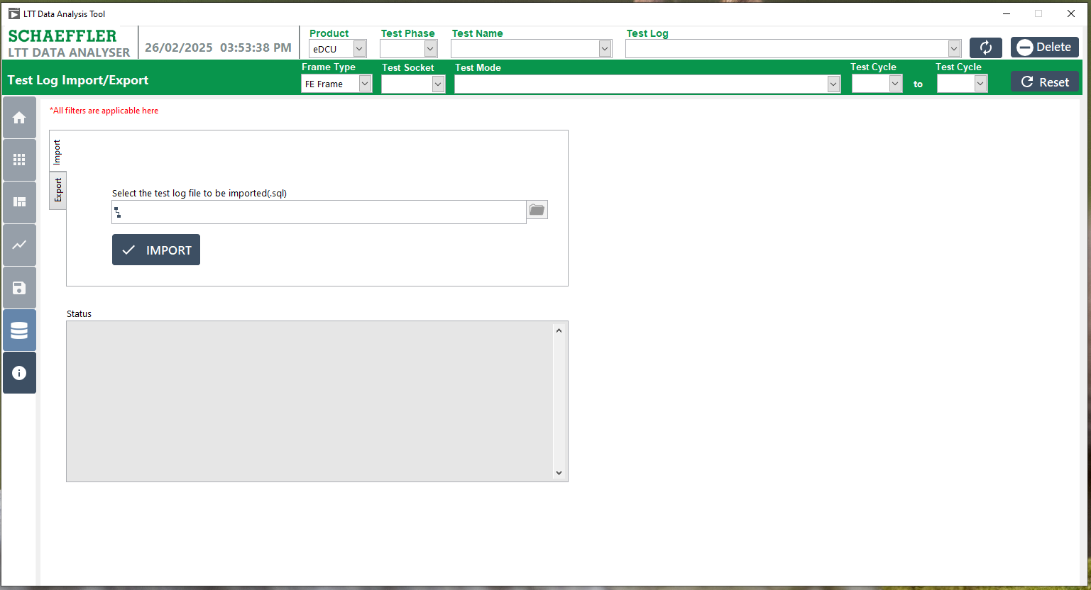
1
3
2
4
Figure 4: Import and Export Screen

Procedure to Import the Test Log

- Click on icon to open the Test Log Import/Export screen.
- Click the "Import" tab button.
- Click the icon to browse the test log file.

2
3
1
Figure 5: Import Database File

Browse Test Log file
- Select the test log file (.SQL) you need to import.
- The selected file name will be displayed.
- Click the "OK" button to proceed.
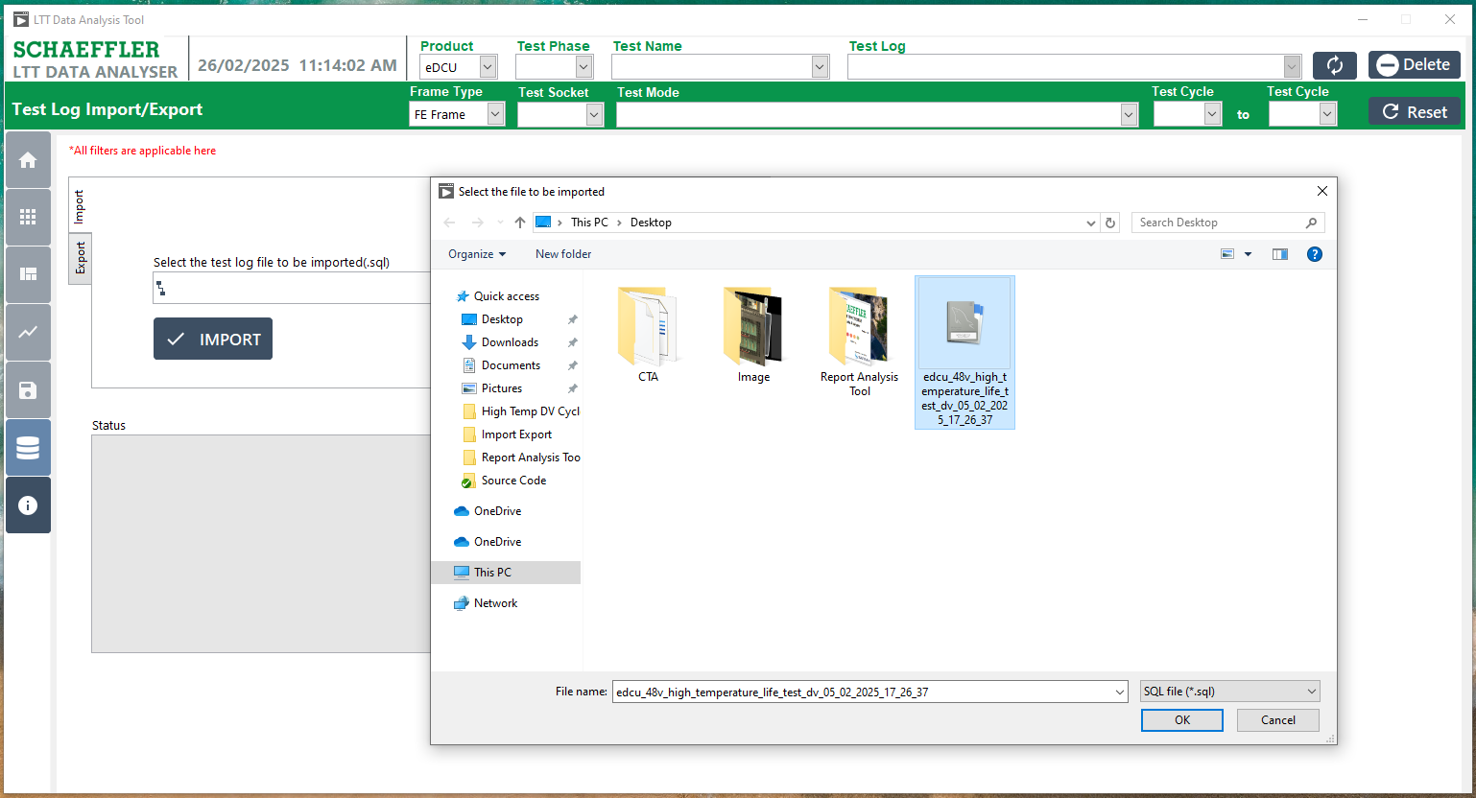
3
2
1
Figure 6: Import Data Selection

Start Importing
- The selected file name will be displayed.
- Click the Import Button.
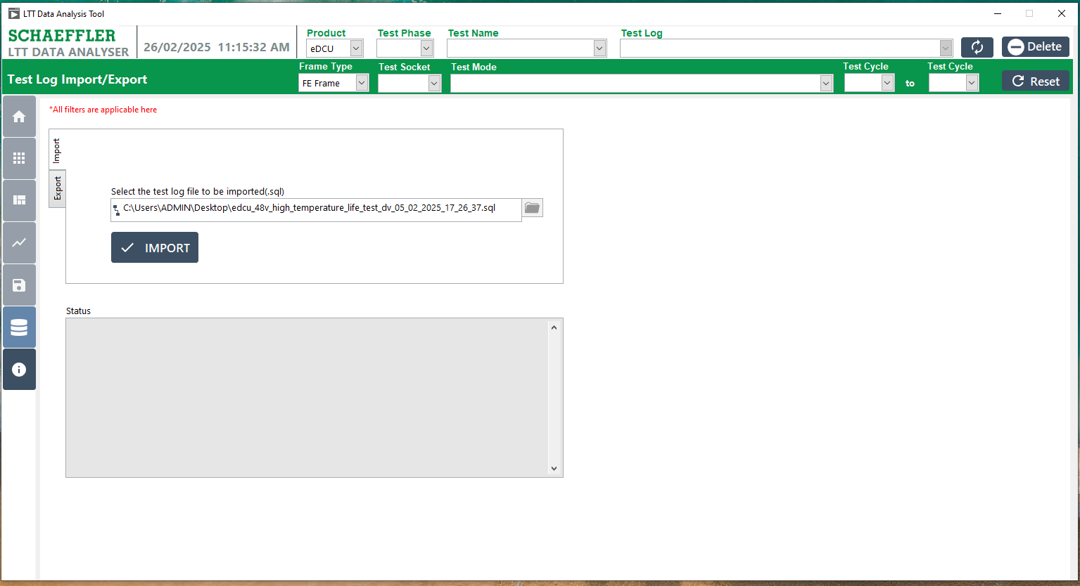
2
1
Figure 7: Import Data File Displayed.

Import in Progress
- After clicking the "Import" button,
- The status for the import file will be displayed, showing the progress of the import process. It may take couple of minutes depending on file size
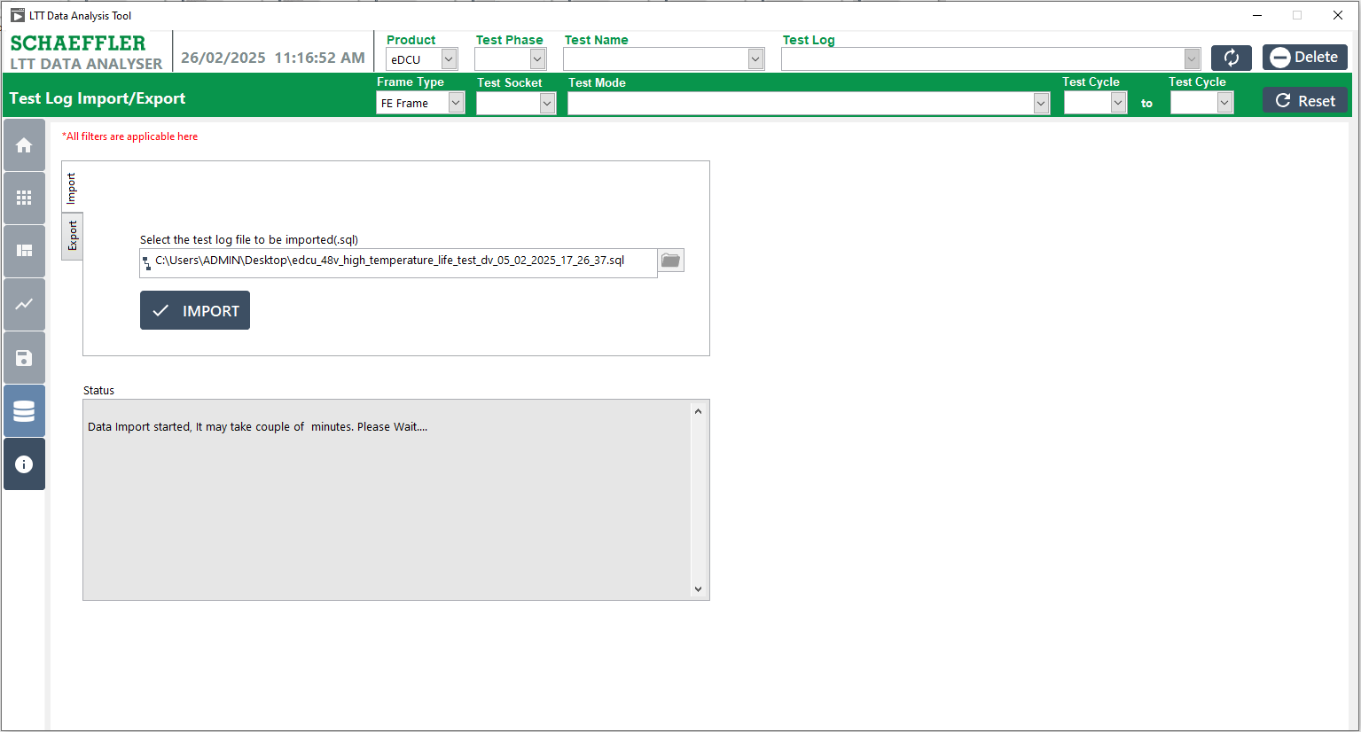
1
2
Figure 8: Import Data Inprograss

Import Successful
- A pop-up will appear confirming that the import has been completed successfully.
- Click the "OK" button to acknowledge and close the pop-up.

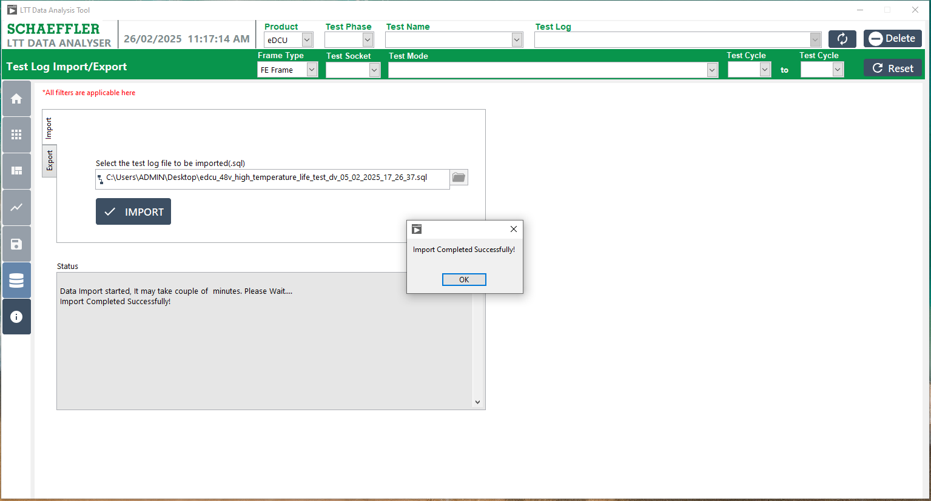
2
1
Figure 9: Import File Successful

Import Status Update
- A message will appear confirming that the import status is completed.

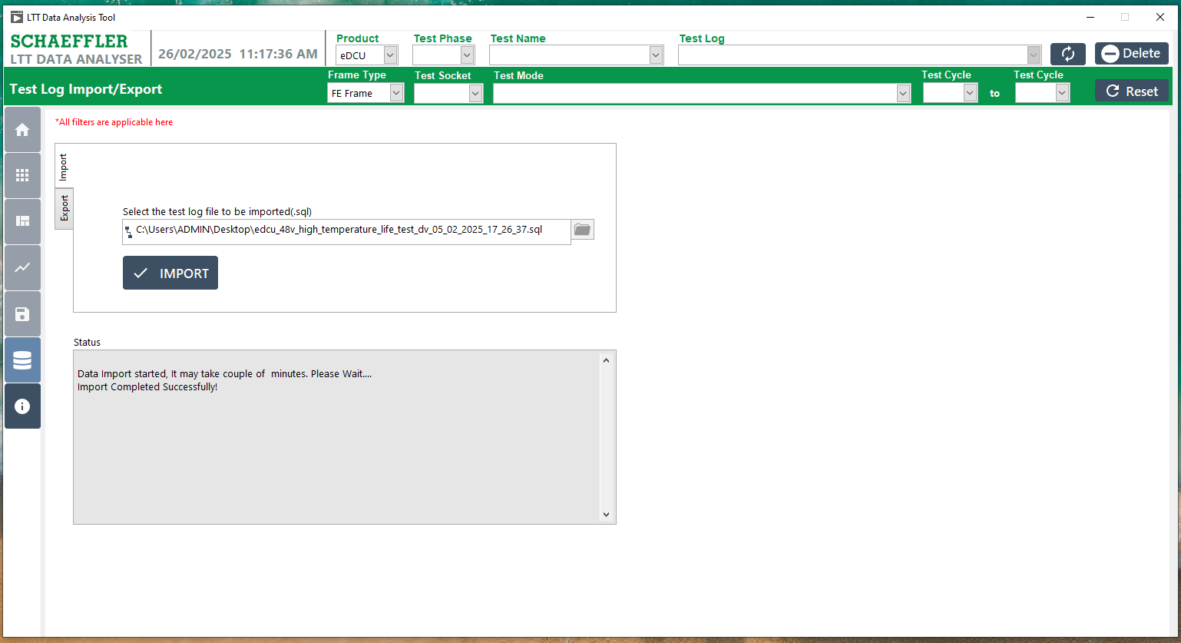
1
Figure 10: Import Status Show for successfully Completed

Procedure to Export theTest Log
- Click the "Import and Export" button to display the screen.
- Click the "Export" tab button.
- Select the Test Log Name from the available list.
- Select the export folder path where the file will be saved.
- After selecting the Test Log Name and the folder path, click the "Export" button to complete the export process.
- The status of the import and export process will be updated with relevant messages.
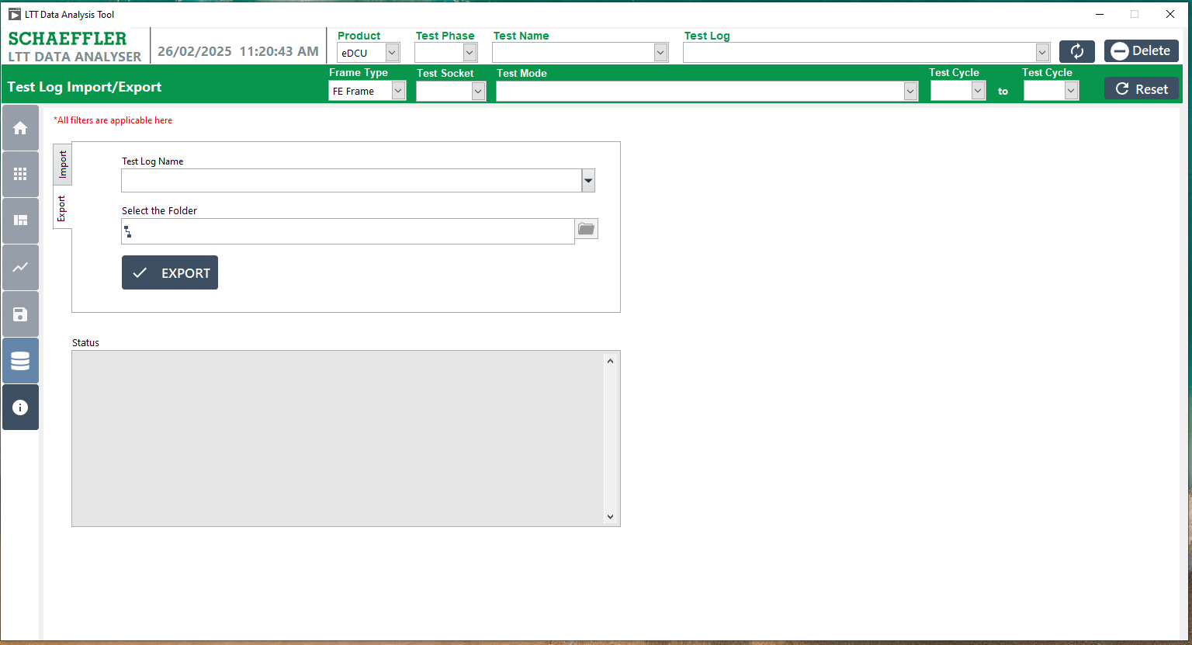
5
4
3
2
1
6
Figure 11: Export the Database File

Browse for Folder Selection
- Select the respective folder path where you want to export the file.
- Click the "Select Folder" button to confirm the selected folder and proceed with the export.
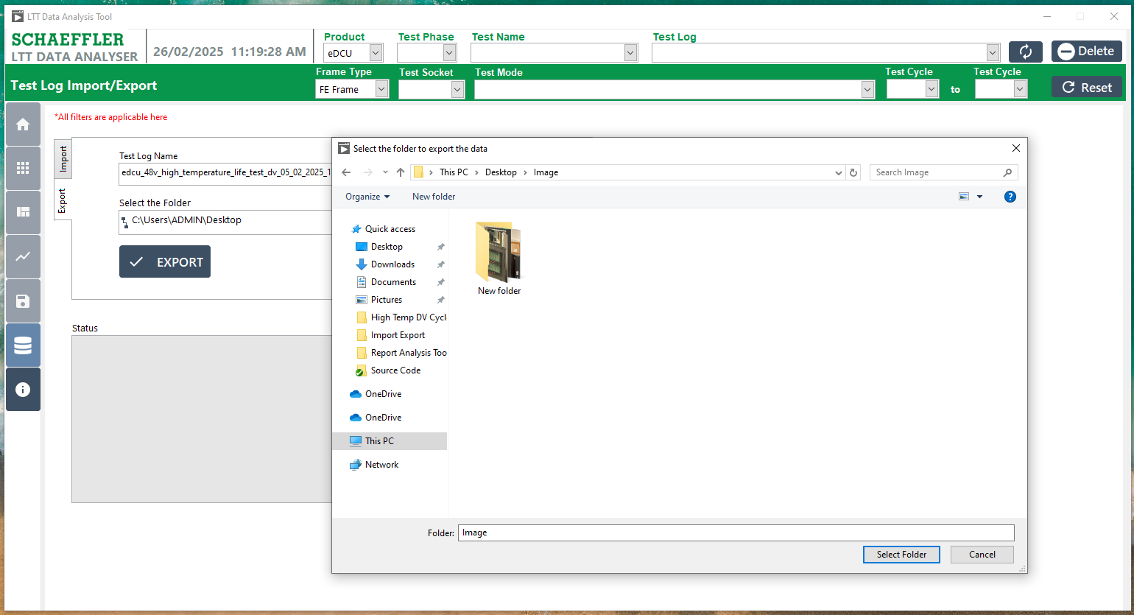
1
2

Figure 12: Export Database File Folder Selection

Export Test log and Status
- The selected file name will be displayed in the Test Log Name field.
- The selected folder name will be displayed in the Export Folder field.
- Click the Export button to start the export process.
- The Export Status will be shown, indicating the progress of the exports.
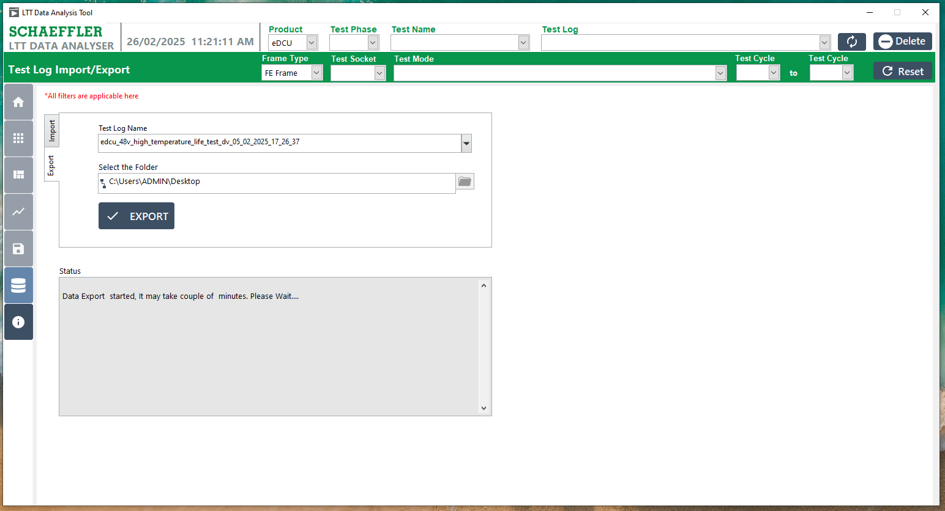
4
3
2
1
Figure 13: Export of the Selected Database File Displayed.

Export Successfully Completed Message
- A message will appear confirming that the import status is completed, such as.
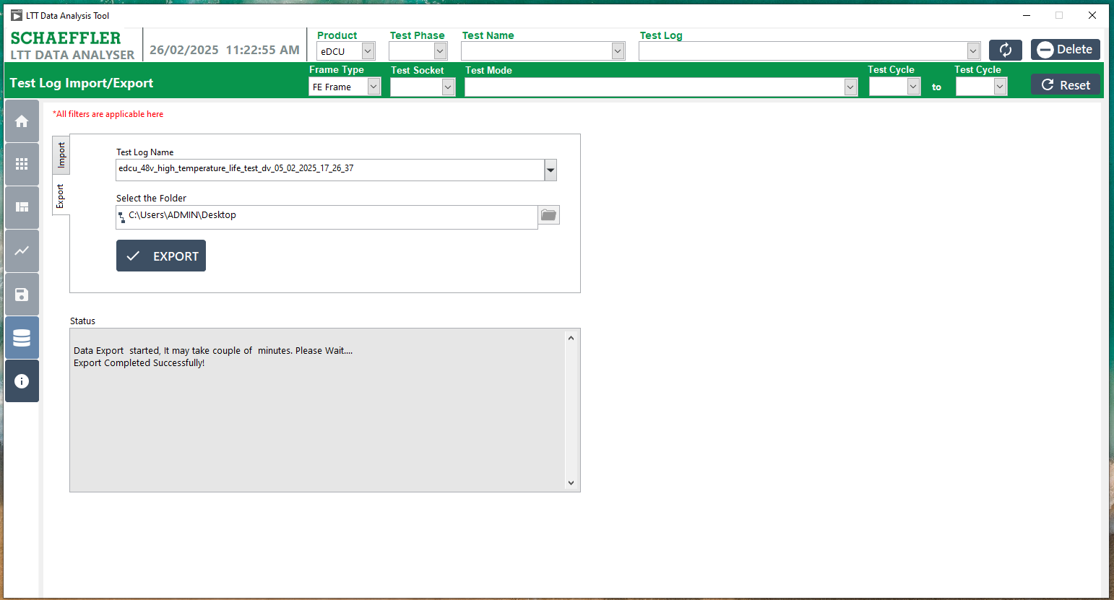
1
Figure 14: Export the Database file Successfully Completed.

Test Log Selection

Choose 'Test Log' to activate the 'Other Data Analysis' button. This will let you view the data by granting access to the data view.
Users can apply filters for Product, Test Phase, and Test Name before selecting the test log. This helps in narrowing down the search efficiently.

6.1 Selected the Test Log Name
- Select the Test Log Name, and once selected, enable all control buttons on the screen to allow full functionality.
- Once the Test Log Name is selected, all control buttons will be enabled, allowing access to the following options.
      - Test Log Import and Export
      - Test Info
      - Error Log
      - FE FF Frame
      - Plot Signals
      - Export

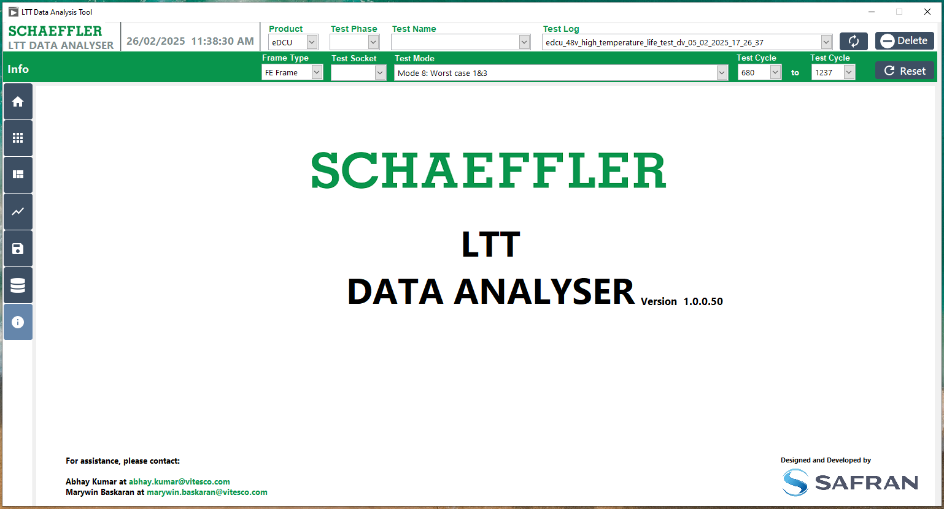
2 showing Popup
1 showing Popup

Figure 15: Test Log Selected

Test Information

7.1 Test Info View
- Click the "Test Info" button, which is represented by the Home Symbol.
- The screen will display the following Date and Time details:
      - Test Start Date
      - Estimated Completion Date
      - Remaining Time
      - Completed Time
- The screen will show the Cycles and Percent details:
      - Total Cycles
      - Cycles Completed
      - Remaining Cycles
      - Completed Percentage
- Test information data will be displayed, including the above details, providing an overview of the test's progress and status.
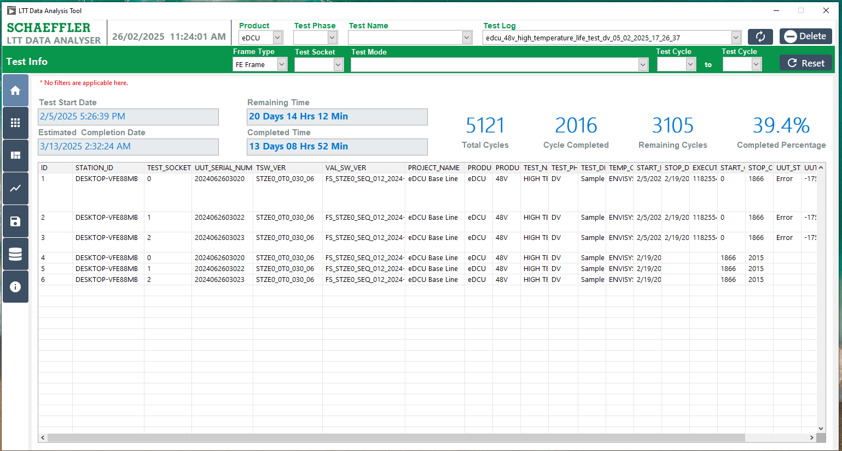
1 showing Popup
2 showing Popup
4 showing Popup
3 showing Popup
Figure 16: Test Information View

Errors Log

In the Error Log View, users can see an overview of all signals that are out of range, categorized by test socket. The view also displays the failure counts. Users can click on any signal to see more details about it, such as limits, cycle, mode, etc., in a tabular format.

Analyzing Error Log
- Click the "Error Log" button, represented by the Dial Symbol.
- The Test Log has already been selected, and the Errors List Table is updated to show the Socket, Error Signal, and Error Count for each specified Socket.
- The Error Log filter is applied for both the Start Test Cycle and Stop Test Cycle.
- Click "Refresh Data" to display the error data.
- The specified errors will be displayed accordingly.

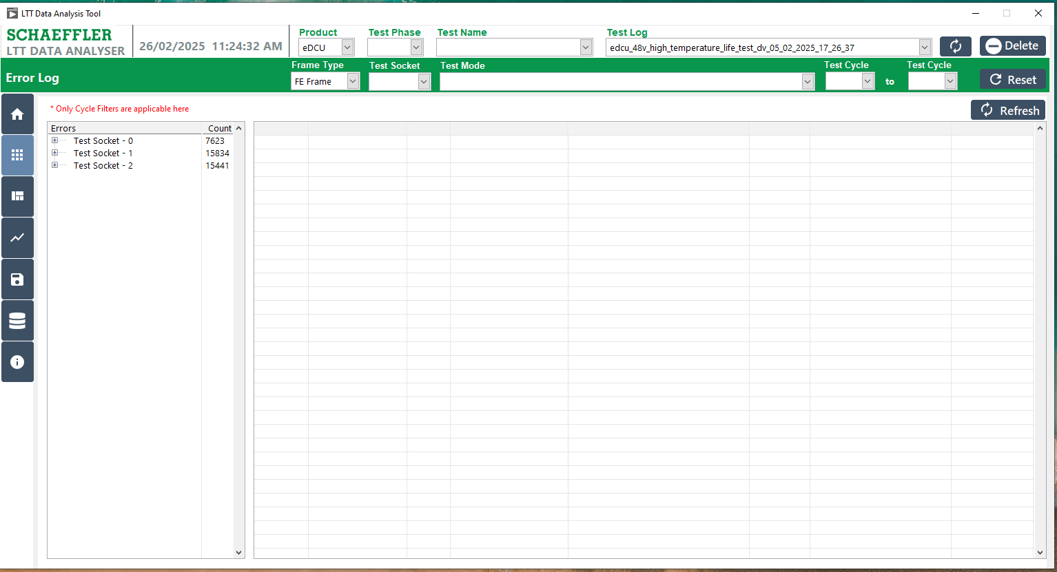
4
3
5
2
1
Figure 17: Procedure for Error Log

Test Socket wise Errors
- Click on the Test Socket to list the associated Error Signals.
- Display the Error Signals.
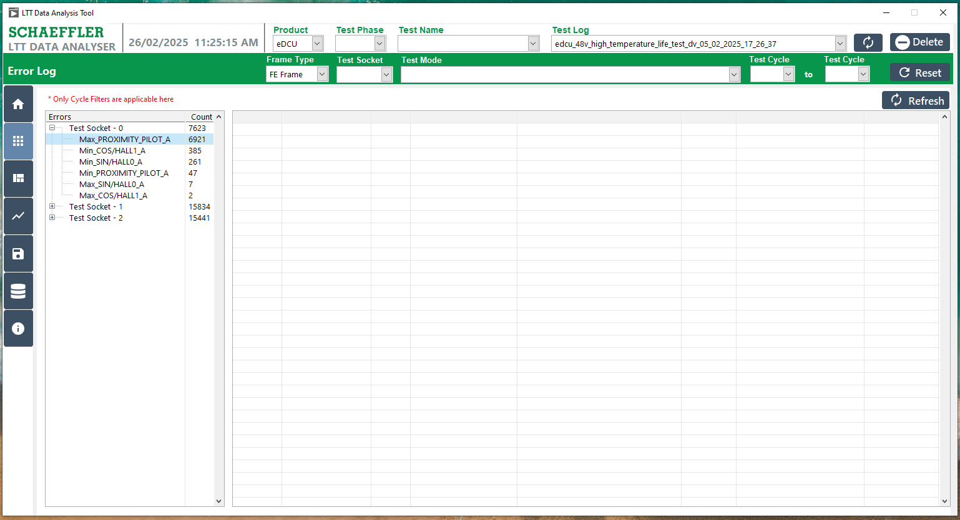
1
2
Figure 18: Error Log – Test Socket and Signal Listed

Signal Selected and View Data
- Click the Selected Signal and Show the Error Count specify signal.
- Selected Signal data Showing the Displayed.
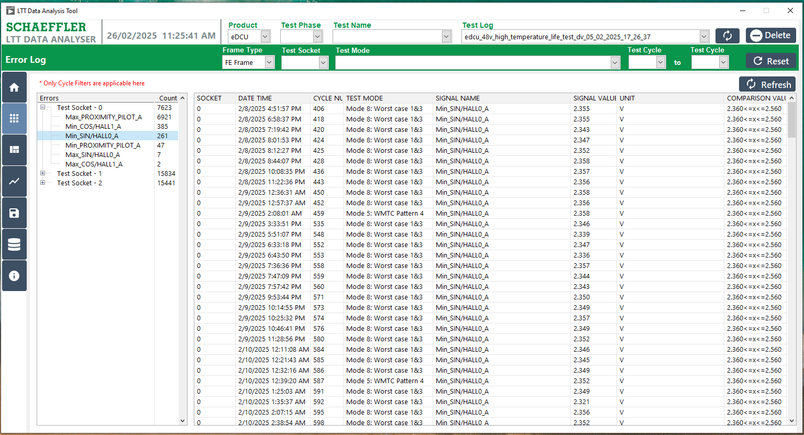
2
1
Figure 19: Error Log Selected Signal and View Data

Selected the Cycle Number based Filter
- Select either the Start Cycle or Stop Cycle to list the errors.
- Click the Refresh Button.
- Choose the Error List from the Signals and Count.
- Display the selected either the Start Cycle or Stop Cycle and Signal.
4
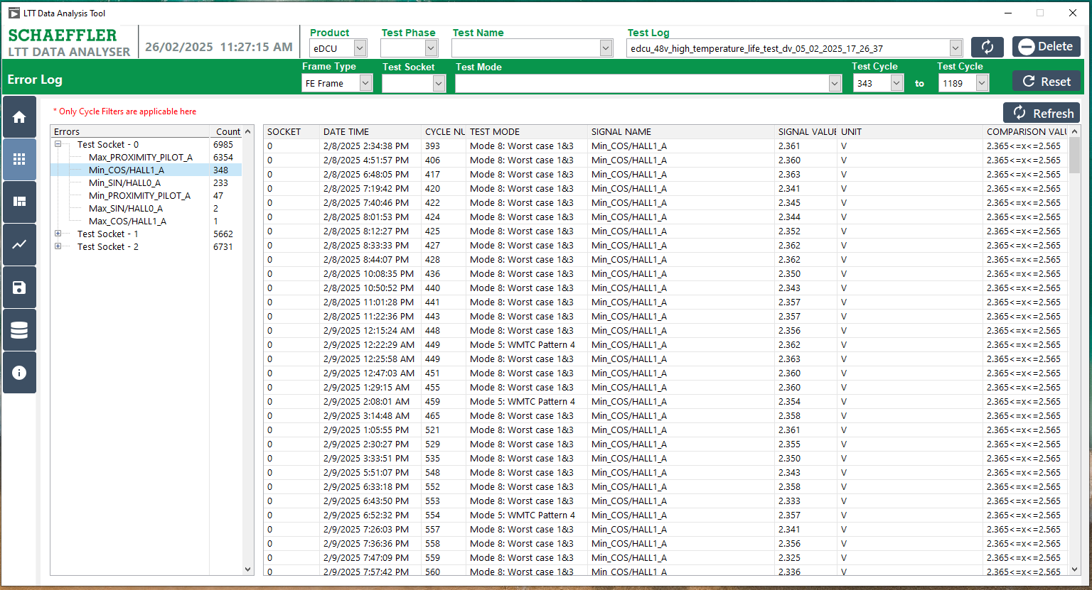
2
2
1
Figure 20: Error Log – Selected Cycle and Data View

View the FE and FF Frames for any Error
- Double-click the specific signal listed in the data.
- Display the selected signal based on the FE and FF frames.
4
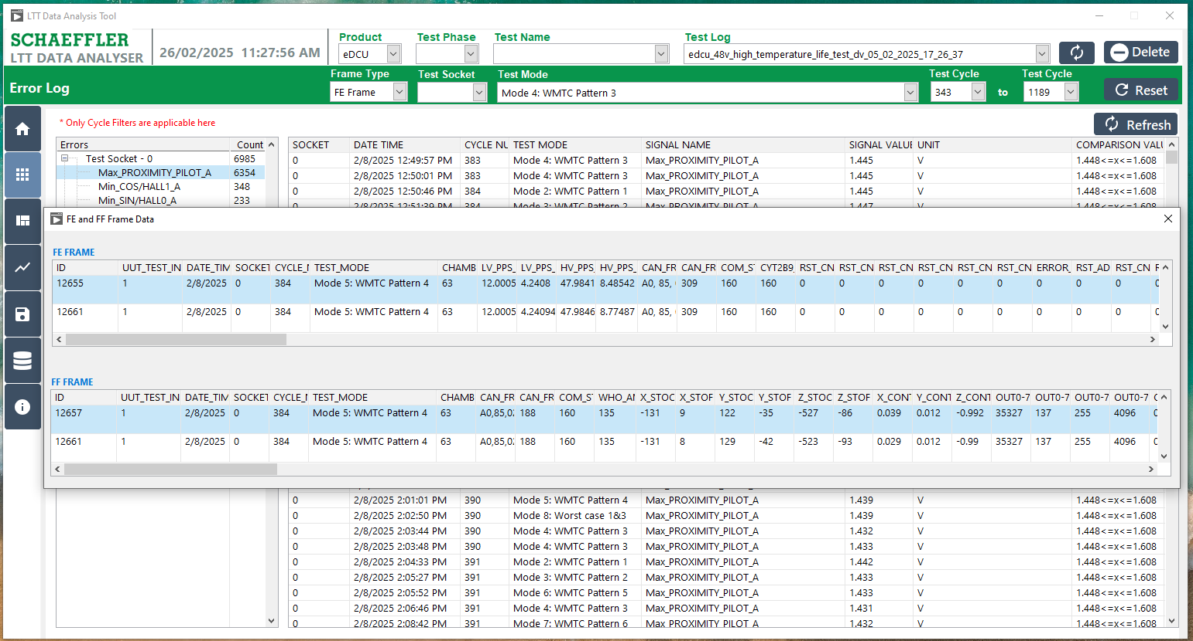
2
1
Figure 21: Error Log – Display FE and FF frames

FE and FF frames

The FE and FF Frame Data View enables users to review FE/FF Frame data based on selected frames. Filters can be applied by Socket, Test mode, Test Cycles and date, time. Additionally, users have the option to export the data in .csv and .xls formats.

FE and FF Frame Data Window
- Click the "FE / FF Frames " button, represented by the Settings Symbol.
- The Test Log has already been selected, and the available filter options include Frame Type, Test Sockets, Test Mode, and Test Start or Stop Cycles.
- Option to apply all data.
- Option to view data by date.
- Option to choose file format (.csv, .xlsx).
- Option to export and save data.
- Display the data after applying the filter.
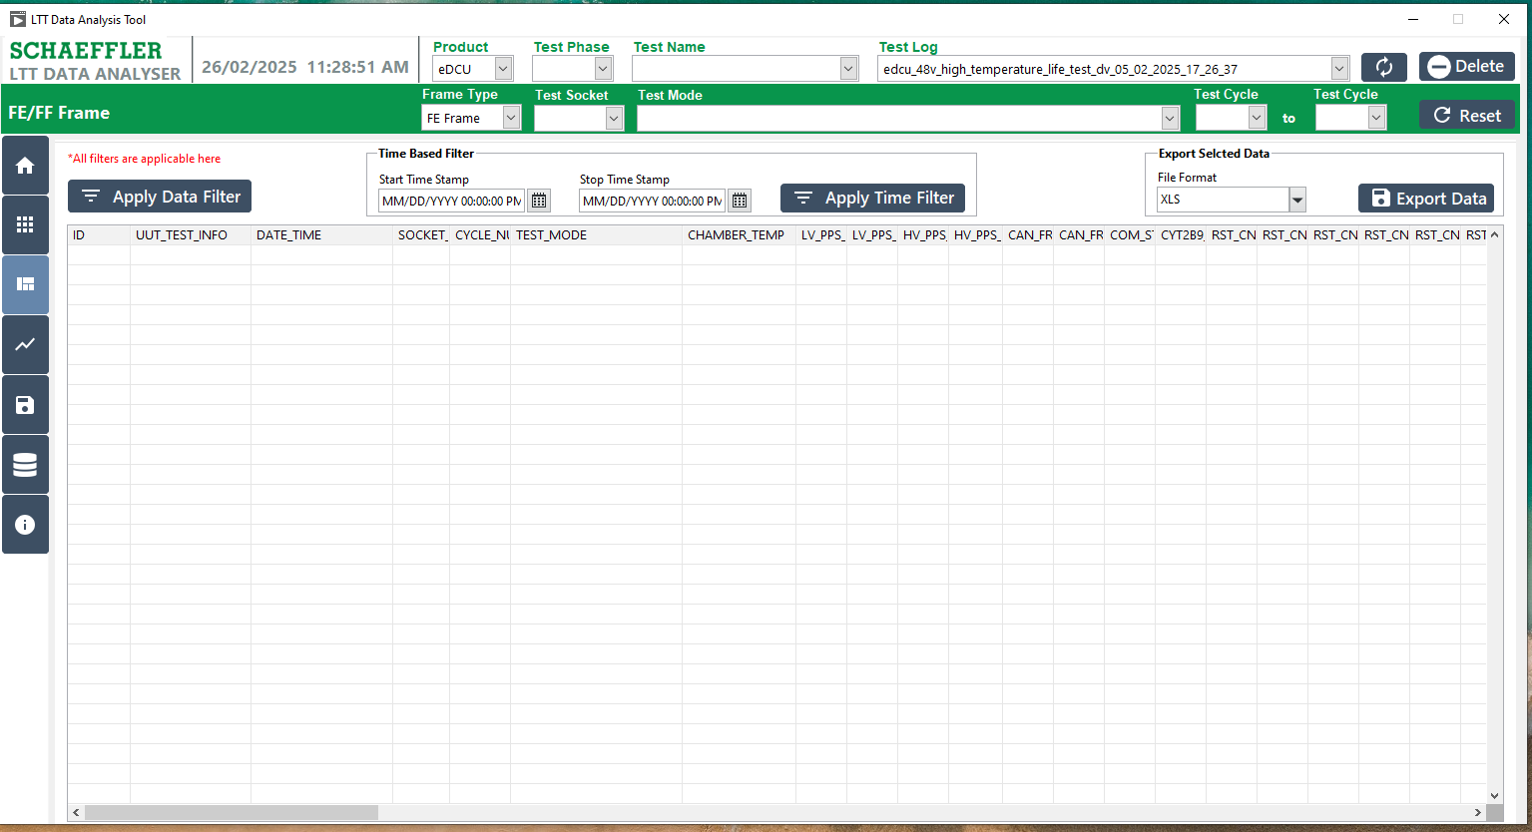
2
7
5
6
4
3
1
Figure 22: FE and FF Frames

Apply the Data Filter
- Click the 'Apply Data Filter' button.
- Display all the data.
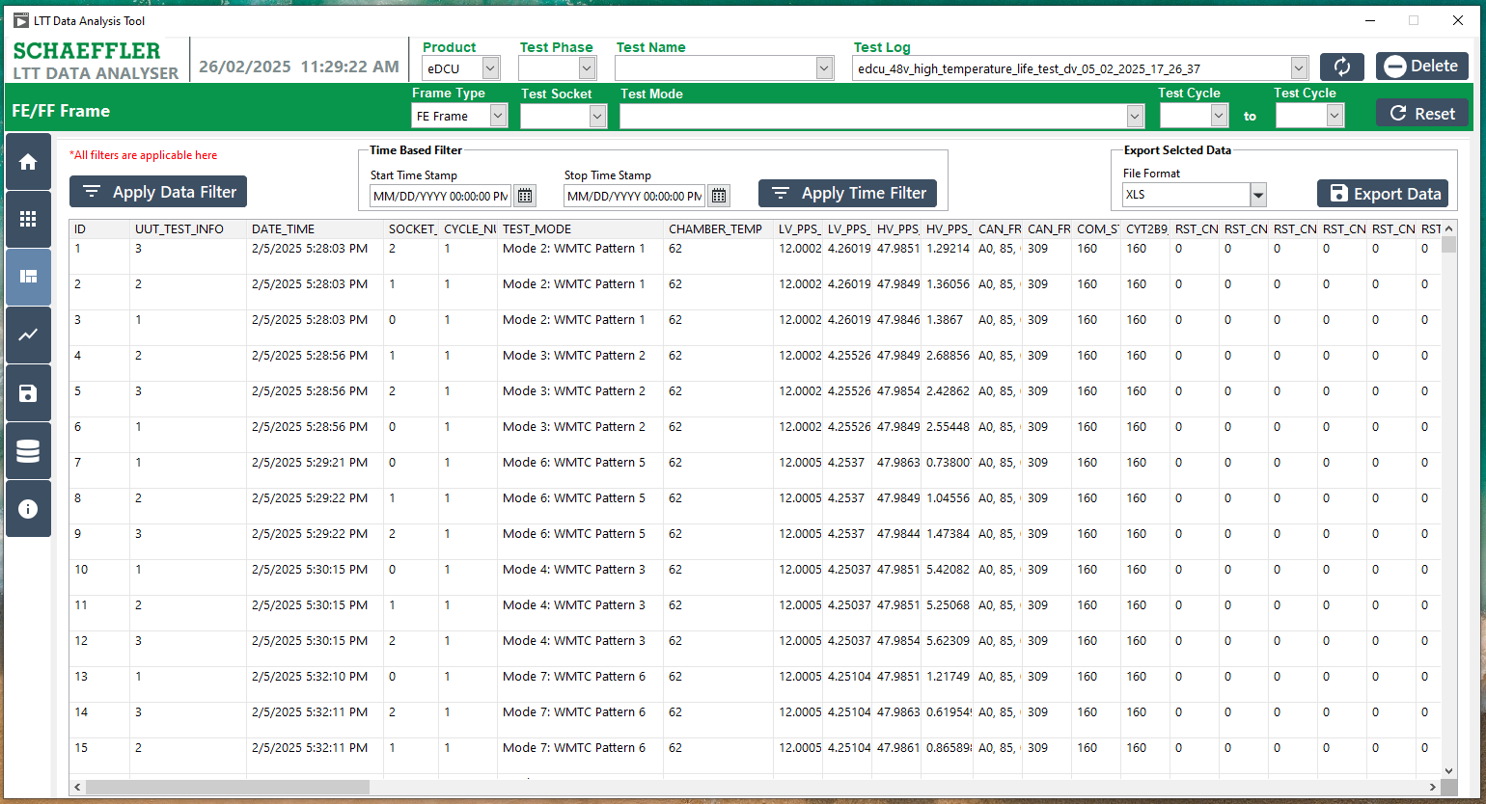
2
1
Figure 23: FE and FF Frames All Data Filter

Apply the Time Based Filter

- Select the Start and Stop Time, then fill in the Date and Time to filter the data.
- Click the "Apply Time Filter" button.
- Display all the data based on the Timestamp filter.
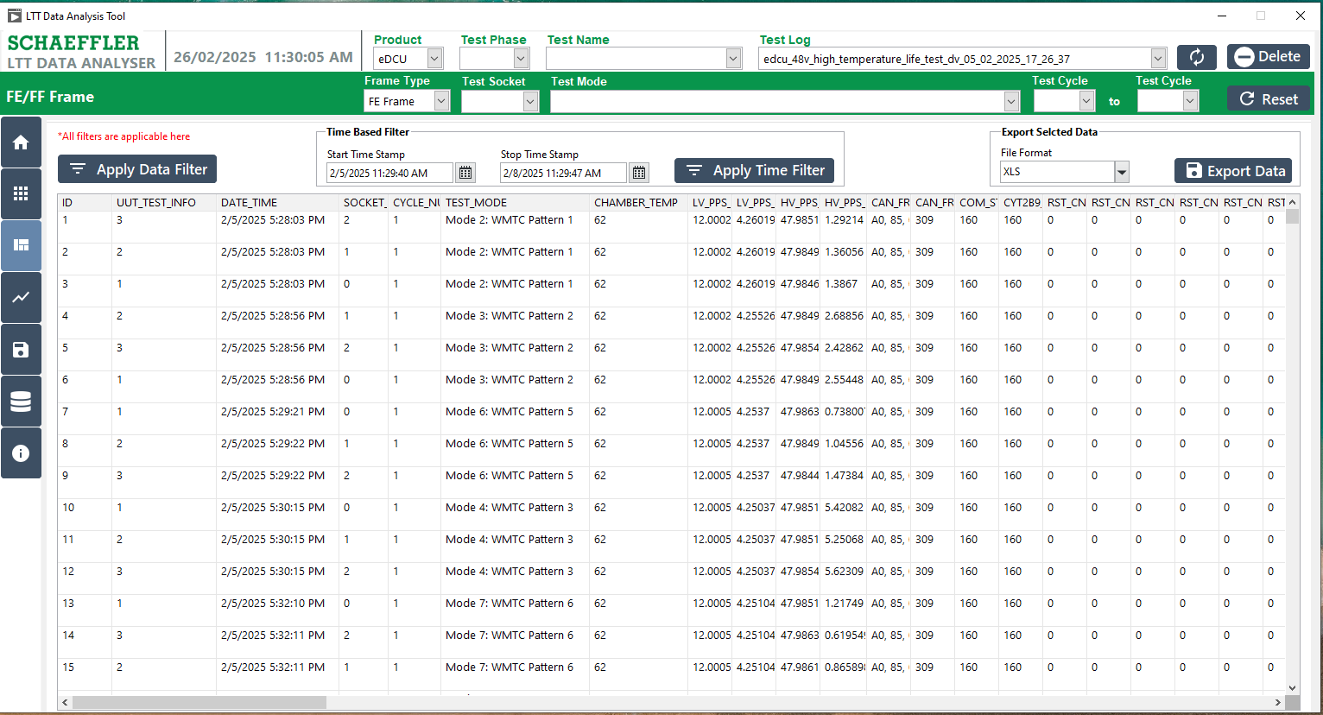
2
1
3
Figure 24: FE and FF Frame Date and Time Filter

9.4 View Selected the Frame
- Select the Frame Type as either FE Frame or FF Frame.
- Click either the "Apply Time Filter" or "Apply Frame Filter" button.
- Display all the data based on the selected FE or FF Frame filter.

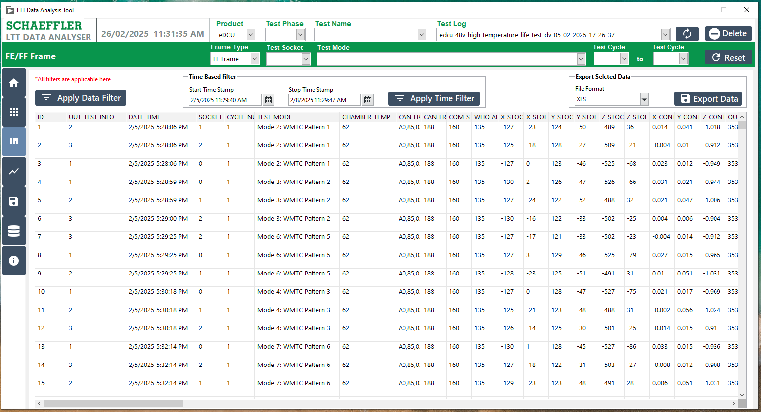
3
2
1
Figure 25: FE and FF Frame Selection Filter

9.5 FE and FF Frame- Mode Filter
- Select the Frame Type as either FE Frame or FF Frame and choose the Test Mode.
- Click either the "Apply Time Filter" or "Apply Frame Filter" button.
- Choose the test socket.
- Select the test cycle start and stop cycles to apply the filter.
- Display all the data based on the selected FE or FF Frame filter and Test Modes.

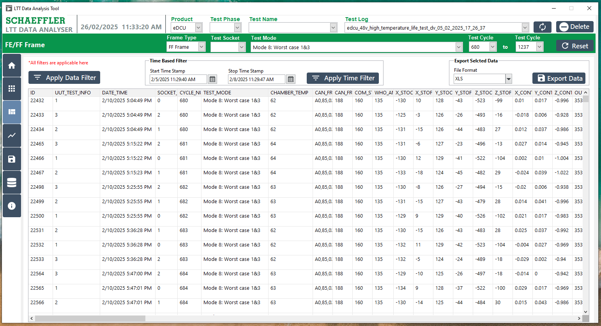
4
3
1
1
2
2
5

Figure 26: FE and FF Frame and Test mode Filters

9.6 Export the Selected Data
- Click either the "Apply Time Filter" or "Apply Frame Filter" button.
- Display all the data based on the selected FE or FF Frame filter.
- Select the desired file format (.xlsx or .csv).
- Click the "Export" button.
- Choose a folder and click the "Select Folder" button.
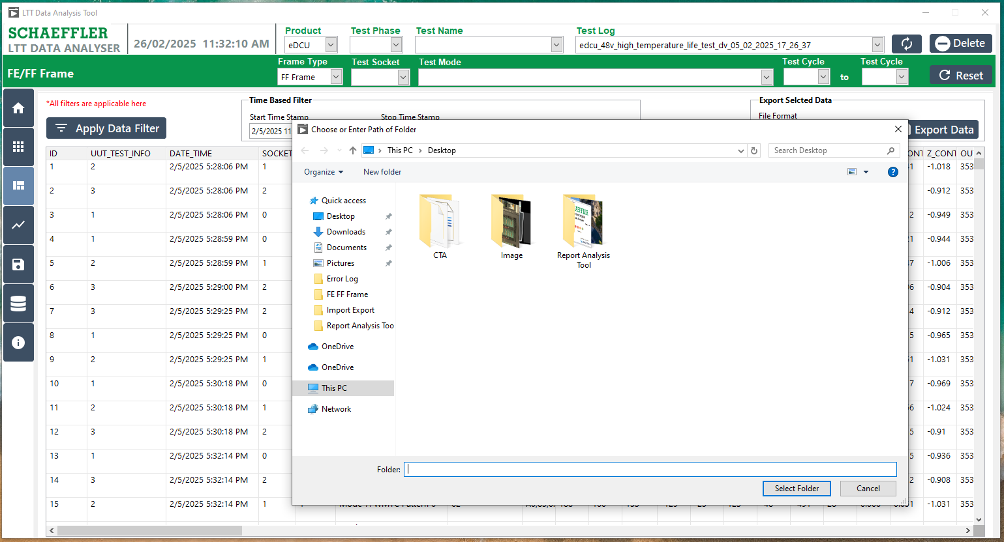
5
1 showing Popup
2 showing Popup
4
3 showing Popup

Figure 27: FE and FF Frame Export Data

Plot Signals

The Signal Analysis feature is utilized to visualize any signal across all sockets for a specified mode, with respect to cycles. This helps in identifying any underlying patterns.

10.1 Procedure for Plot Signals:
- Selected the Test Log
- Click the "Plot Signals" button, represented by the Graph Symbol.
- The Test Log has already been selected, this filter is Mandatory Frame Type, Test Mode and the available filter options include Test Sockets, and Test Start or Stop Cycles.
- Select the Signal Name and click the "Apply Plot Signal" button.
- The respective signal graph will be displayed.
- Alternatively, select another Signal Name and click the "Apply Plot Signal" button.
- The respective signal graph for the second signal will be displayed.
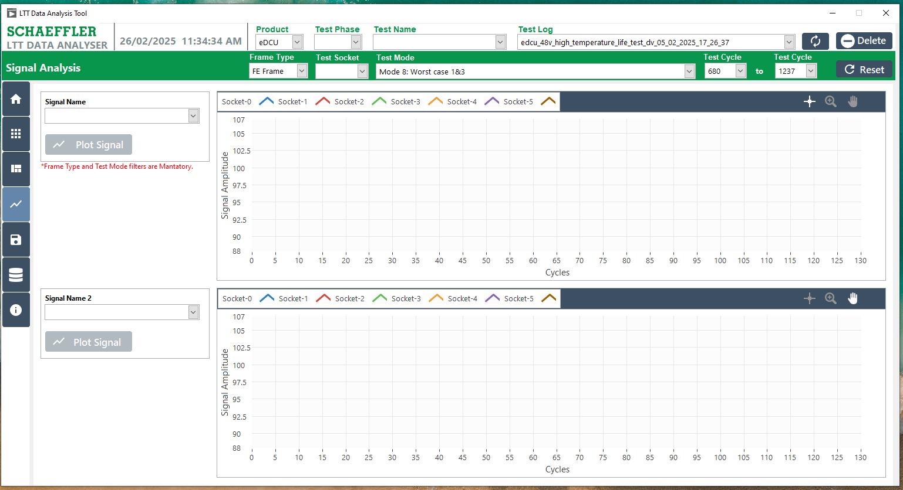
3 showing Popup
4 showing Popup
6 showing Popup
7 showing Popup
5 showing Popup
1 showing Popup
2 showing Popup

Figure 28: Procedure for Plot Signals

10.2 Procedure for Validation of the Signals:
- The Test Log has already been selected, this filter is Mandatory Frame Type, Test Mode and the available filter options include Test Sockets, and Test Start or Stop Cycles.
- Select the Signal Name and click the "Apply Plot Signal" button.
- The respective signal graph will be displayed.
- Alternatively, select another Signal Name and click the "Apply Plot Signal" button.
- The respective signal graph for the second signal will be displayed.

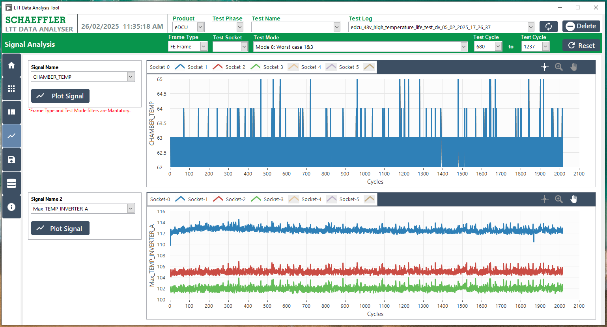
5 showing Popup
4 showing Popup
3 showing Popup
2 showing Popup
1 showing Popup

Figure 29: Plot Signals - Validation

Export Data

The Data Export feature allows users to export any table from the test log into .csv or .xls formats. This facilitates easy data sharing and enables further analysis using other tools.

11.1 Export the Data Window
- Selected the Test Log
- Click the "Export Data" button, represented by the File Symbol.
- Select the table name.
- The data for the selected table will be displayed.
- Choose the desired file format (.xlsx or .csv).
- Export the data in the selected file format.

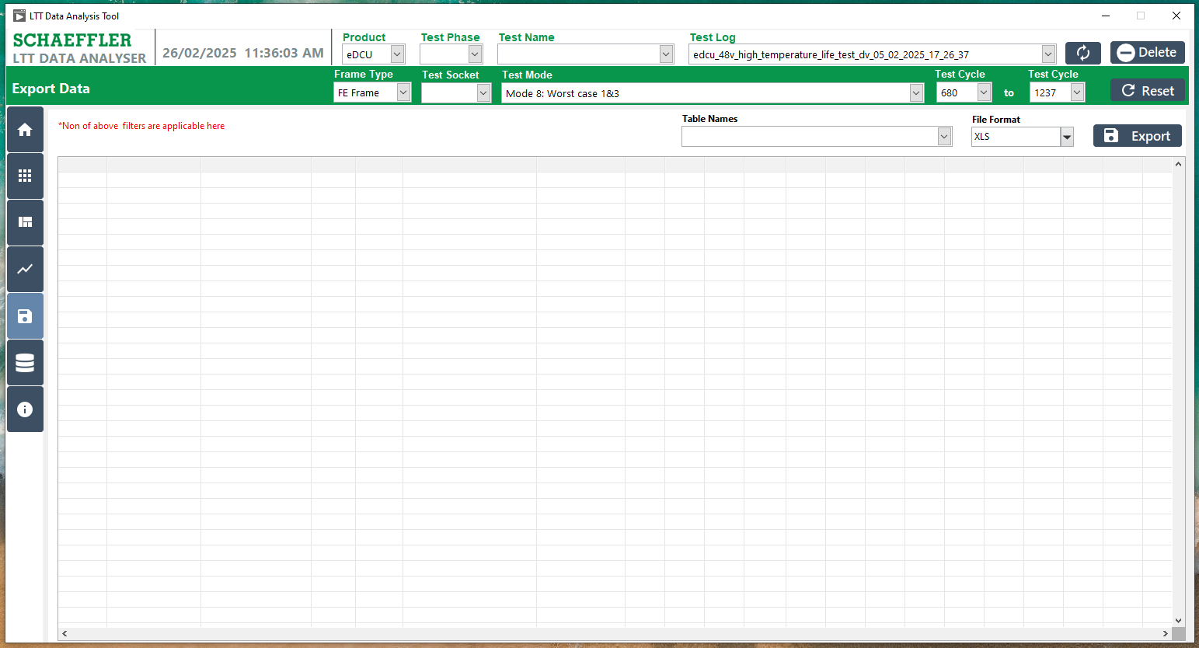
6 showing Popup
5 showing Popup
4 showing Popup
3 showing Popup
2 showing Popup
1 Popup

Figure 30: Procedure the Export Data

11.2 Select the Table
- Select the table name.
- The data for the selected table will be displayed.
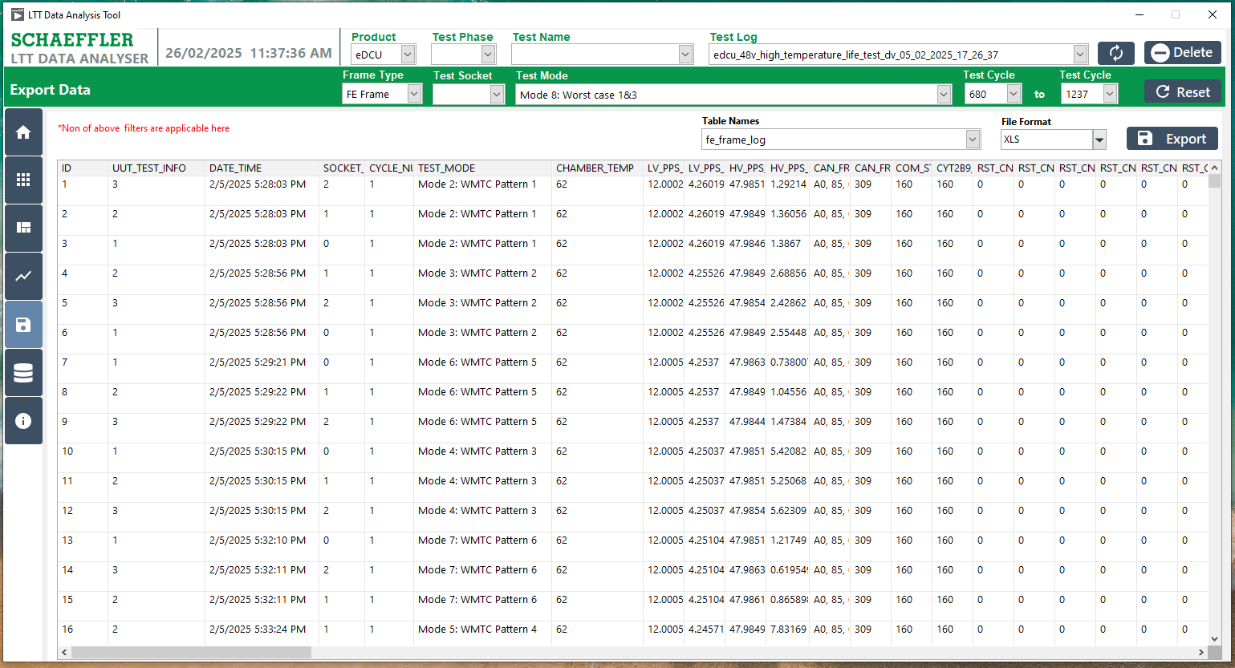
2 showing Popup
1 showing Popup

Figure 31: Export Data – Selected Table and Show Data.

11.3 Export the Data
- Select the table name.
- The data for the selected table will be displayed.
- Choose the desired file format (.xlsx or .csv).
- Export the data in the selected file format.
- Choose a folder and click the "Select Folder" button.

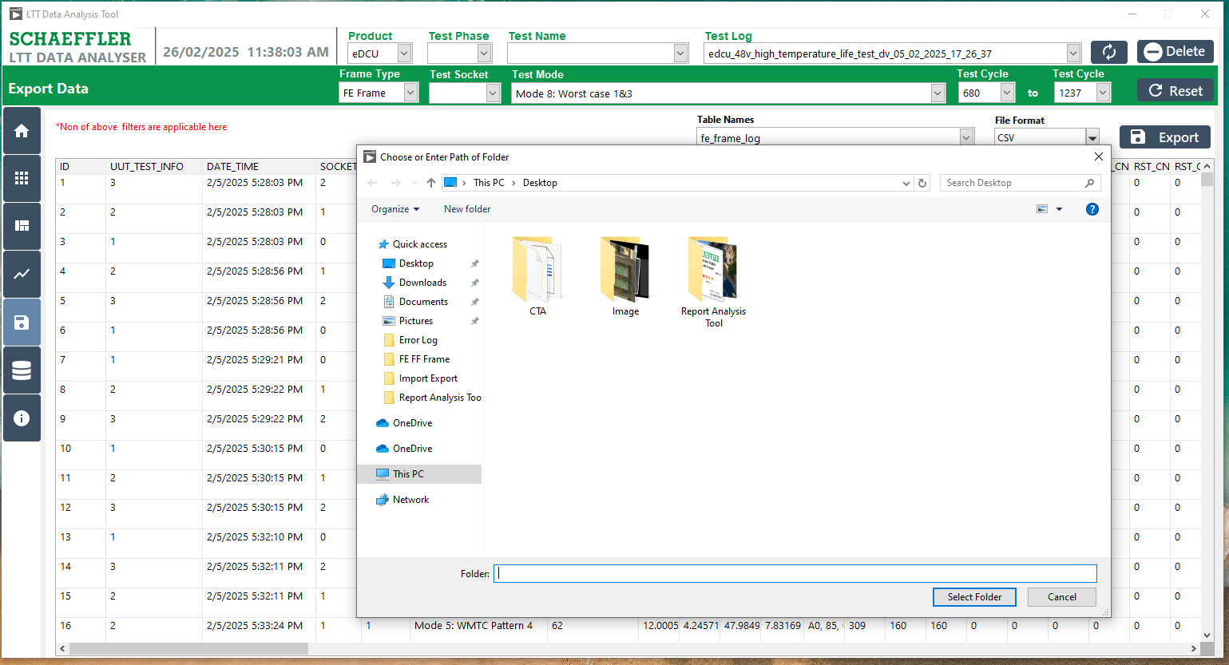
5
4 showing Popup
3 showing Popup
2 showing Popup
1 showing Popup

Figure 32: Export Data as File Format

